Stats Video Lectures – Introduction to Inference

Week 1, Video 12

1. case study: gender discrimination in promotions
   1. 48 male bank supervisors were given the same personelle file, asked if they person should be promoted
   2. files were identical except for gender
   3. random assignedment
   4. 35/48 promoted
   5. were the females unfairly discriminated against?

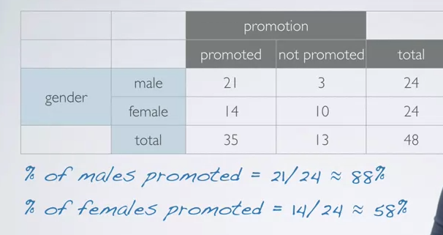

* 1. H0: this could be due to chance, promotion and gender are independent
  2. HA: there is gender discrimination, promotion and gender are dependent

1. Simple Inference using a simulation model
   1. use a deck of playing cards to simulation
   2. face card =not promoted a, k,q,j
   3. number card = promoted
   4. remove enough cards so that we have 48 cards, keeping to the 35 promoted and 13 not promoted ratio
   5. shuffle cards into 2 groups of 24 of male and female
   6. count the number of number vs face card to see how many males and females were promoted

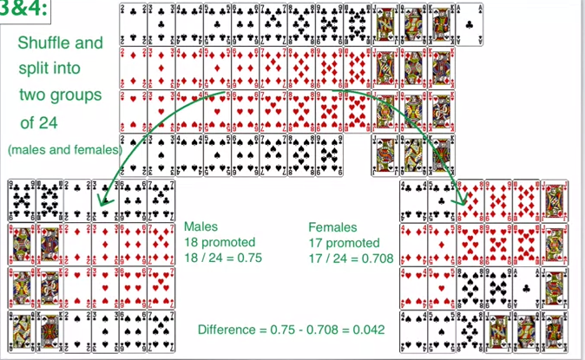

* 1. repeat… lots, each time calculation the difference of promotion proportion.. we’d expect the difference to be nearly zero if this is truly a random chance.
  2. plot the repeated experiment outcomes on a dot plot

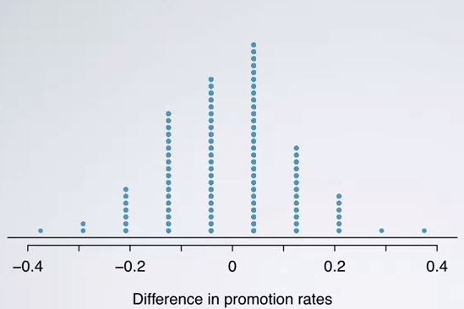

* 1. if the results of the simulation looks like the data, we know that the promotion proportion is due to chance and thus independent.
  2. since our observed difference was 30% which is waaaay far away from the null hypothesis of zero, we can assume promotion and gender are dependent, and there is gender bias in promotion rates

1. p-value: evaluating the probability of observing an outcome at least as extreme as the one observed in the original data